**MOHAMED AHMED SHEIKH J17-5075-2023**

**EVENT DRIVEN CAT**

**Registration Project**

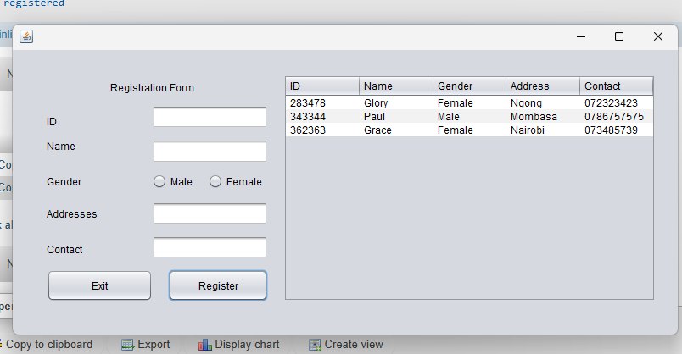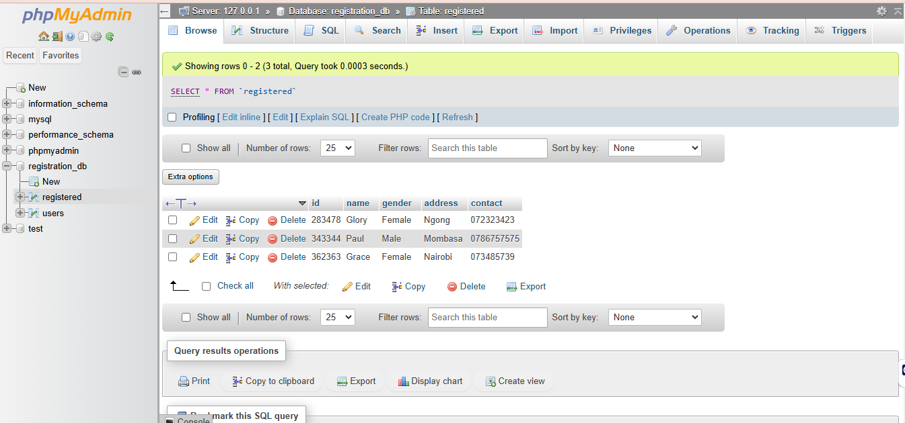

**This is the source code for Registration2Frame of my Project above:**

import javax.swing.table.DefaultTableModel;

import java.sql.Connection;

import java.sql.*;

import java.sql.DriverManager;

import java.sql.SQLException;

import javax.swing.JOptionPane;

/*

* Click nbfs://nbhost/SystemFileSystem/Templates/Licenses/license-default.txt to change this license

* Click nbfs://nbhost/SystemFileSystem/Templates/GUIForms/JFrame.java to edit this template

*/

/**

*

* @author ADMIN

*/

public class Registration2Frame extends javax.swing.JFrame {

/**

* Creates new form Registration2Frame

*/

public Registration2Frame() {

initComponents();

Connection con = Registration1Frame.DBConnection.connect();

if (con != null) {

System.out.println("Connection object created successfully.");

loadTableData();

} else {

System.out.println("Failed to create a connection object. Check your DB configuration.");

}

}

private void clearFields() {

idTextField.setText("");

nameTextField.setText("");

contactTextField.setText("");

addressTextField.setText("");

buttonGroup1.clearSelection();

}

public class DBConnection {

public static Connection connect() {

Connection con = null;

try {

String url = "jdbc:mysql://localhost:3306/registration_db";

String user = "root"; // Default username for XAMPP

String password = ""; // Default password for XAMPP (blank)

Class.forName("com.mysql.cj.jdbc.Driver");

con = DriverManager.getConnection(url, user, password);

System.out.println("Database connected successfully!");

} catch (ClassNotFoundException e) {

System.err.println("JDBC Driver not found: " + e.getMessage());

} catch (SQLException e) {

System.err.println("Error connecting to database: " + e.getMessage());

}

return con;

}

}

/**

* This method is called from within the constructor to initialize the form.

* WARNING: Do NOT modify this code. The content of this method is always

* regenerated by the Form Editor.

*/

@SuppressWarnings("unchecked")

// <editor-fold defaultstate="collapsed" desc="Generated Code">

private void initComponents() {

buttonGroup1 = new javax.swing.ButtonGroup();

jLabel1 = new javax.swing.JLabel();

jLabel2 = new javax.swing.JLabel();

jLabel3 = new javax.swing.JLabel();

jLabel4 = new javax.swing.JLabel();

jLabel5 = new javax.swing.JLabel();

jLabel6 = new javax.swing.JLabel();

idTextField = new javax.swing.JTextField();

nameTextField = new javax.swing.JTextField();

addressTextField = new javax.swing.JTextField();

contactTextField = new javax.swing.JTextField();

maleButton = new javax.swing.JRadioButton();

femaleButton = new javax.swing.JRadioButton();

exitButton = new javax.swing.JButton();

registerButton = new javax.swing.JButton();

jScrollPane2 = new javax.swing.JScrollPane();

jTable1 = new javax.swing.JTable();

setDefaultCloseOperation(javax.swing.WindowConstants.EXIT_ON_CLOSE);

jLabel1.setText("ID");

jLabel2.setText("Name");

jLabel3.setText("Gender");

jLabel4.setText("Addresses");

jLabel5.setText("Contact");

jLabel6.setText("Registration Form");

buttonGroup1.add(maleButton);

maleButton.setText("Male");

buttonGroup1.add(femaleButton);

femaleButton.setText("Female");

femaleButton.addActionListener(new java.awt.event.ActionListener() {

public void actionPerformed(java.awt.event.ActionEvent evt) {

femaleButtonActionPerformed(evt);

}

});

exitButton.setText("Exit");

exitButton.addActionListener(new java.awt.event.ActionListener() {

public void actionPerformed(java.awt.event.ActionEvent evt) {

exitButtonActionPerformed(evt);

}

});

registerButton.setText("Register");

registerButton.addActionListener(new java.awt.event.ActionListener() {

public void actionPerformed(java.awt.event.ActionEvent evt) {

registerButtonActionPerformed(evt);

}

});

jTable1.setModel(new javax.swing.table.DefaultTableModel(

new Object [][] {

{null, null, null, null, null},

{null, null, null, null, null},

{null, null, null, null, null},

{null, null, null, null, null}

},

new String [] {

"ID", "Name", "Gender", "Address", "Contact"

}

) {

Class[] types = new Class [] {

java.lang.String.class, java.lang.String.class, java.lang.String.class, java.lang.String.class, java.lang.String.class

};

public Class getColumnClass(int columnIndex) {

return types [columnIndex];

}

});

jScrollPane2.setViewportView(jTable1);

javax.swing.GroupLayout layout = new javax.swing.GroupLayout(getContentPane());

getContentPane().setLayout(layout);

layout.setHorizontalGroup(

layout.createParallelGroup(javax.swing.GroupLayout.Alignment.LEADING)

.addGroup(layout.createSequentialGroup()

.addGroup(layout.createParallelGroup(javax.swing.GroupLayout.Alignment.LEADING)

.addGroup(layout.createSequentialGroup()

.addGap(40, 40, 40)

.addGroup(layout.createParallelGroup(javax.swing.GroupLayout.Alignment.LEADING, false)

.addGroup(layout.createSequentialGroup()

.addGroup(layout.createParallelGroup(javax.swing.GroupLayout.Alignment.LEADING)

.addComponent(jLabel1)

.addComponent(jLabel2)

.addComponent(jLabel3)

.addComponent(jLabel5)

.addComponent(jLabel4))

.addGap(64, 64, 64)

.addGroup(layout.createParallelGroup(javax.swing.GroupLayout.Alignment.LEADING, false)

.addComponent(nameTextField, javax.swing.GroupLayout.DEFAULT_SIZE, 137, Short.MAX_VALUE)

.addComponent(idTextField)

.addComponent(addressTextField)

.addGroup(layout.createSequentialGroup()

.addComponent(maleButton)

.addGap(18, 18, 18)

.addComponent(femaleButton))

.addComponent(contactTextField)))

.addGroup(layout.createSequentialGroup()

.addComponent(exitButton, javax.swing.GroupLayout.PREFERRED_SIZE, 125, javax.swing.GroupLayout.PREFERRED_SIZE)

.addGap(18, 18, 18)

.addComponent(registerButton, javax.swing.GroupLayout.DEFAULT_SIZE, javax.swing.GroupLayout.DEFAULT_SIZE, Short.MAX_VALUE))))

.addGroup(layout.createSequentialGroup()

.addGap(115, 115, 115)

.addComponent(jLabel6)))

.addGap(18, 18, 18)

.addComponent(jScrollPane2, javax.swing.GroupLayout.PREFERRED_SIZE, 439, javax.swing.GroupLayout.PREFERRED_SIZE)

.addContainerGap(26, Short.MAX_VALUE))

);

layout.setVerticalGroup(

layout.createParallelGroup(javax.swing.GroupLayout.Alignment.LEADING)

.addGroup(javax.swing.GroupLayout.Alignment.TRAILING, layout.createSequentialGroup()

.addGap(29, 29, 29)

.addGroup(layout.createParallelGroup(javax.swing.GroupLayout.Alignment.TRAILING)

.addComponent(jScrollPane2, javax.swing.GroupLayout.PREFERRED_SIZE, 0, Short.MAX_VALUE)

.addGroup(layout.createSequentialGroup()

.addGroup(layout.createParallelGroup(javax.swing.GroupLayout.Alignment.LEADING)

.addGroup(layout.createSequentialGroup()

.addGap(47, 47, 47)

.addComponent(jLabel1)

.addPreferredGap(javax.swing.LayoutStyle.ComponentPlacement.UNRELATED, javax.swing.GroupLayout.DEFAULT_SIZE, Short.MAX_VALUE))

.addGroup(javax.swing.GroupLayout.Alignment.TRAILING, layout.createSequentialGroup()

.addComponent(jLabel6, javax.swing.GroupLayout.PREFERRED_SIZE, 30, javax.swing.GroupLayout.PREFERRED_SIZE)

.addPreferredGap(javax.swing.LayoutStyle.ComponentPlacement.RELATED, javax.swing.GroupLayout.DEFAULT_SIZE, Short.MAX_VALUE)

.addComponent(idTextField, javax.swing.GroupLayout.PREFERRED_SIZE, javax.swing.GroupLayout.DEFAULT_SIZE, javax.swing.GroupLayout.PREFERRED_SIZE)

.addPreferredGap(javax.swing.LayoutStyle.ComponentPlacement.UNRELATED)))

.addGroup(layout.createParallelGroup(javax.swing.GroupLayout.Alignment.LEADING)

.addComponent(jLabel2)

.addComponent(nameTextField, javax.swing.GroupLayout.PREFERRED_SIZE, 29, javax.swing.GroupLayout.PREFERRED_SIZE))

.addPreferredGap(javax.swing.LayoutStyle.ComponentPlacement.UNRELATED)

.addGroup(layout.createParallelGroup(javax.swing.GroupLayout.Alignment.BASELINE)

.addComponent(jLabel3)

.addComponent(maleButton)

.addComponent(femaleButton))

.addGap(15, 15, 15)

.addGroup(layout.createParallelGroup(javax.swing.GroupLayout.Alignment.BASELINE)

.addComponent(jLabel4)

.addComponent(addressTextField, javax.swing.GroupLayout.PREFERRED_SIZE, 28, javax.swing.GroupLayout.PREFERRED_SIZE))

.addGroup(layout.createParallelGroup(javax.swing.GroupLayout.Alignment.LEADING)

.addGroup(layout.createSequentialGroup()

.addGap(20, 20, 20)

.addComponent(jLabel5)

.addGap(16, 16, 16))

.addGroup(javax.swing.GroupLayout.Alignment.TRAILING, layout.createSequentialGroup()

.addPreferredGap(javax.swing.LayoutStyle.ComponentPlacement.RELATED)

.addComponent(contactTextField, javax.swing.GroupLayout.PREFERRED_SIZE, javax.swing.GroupLayout.DEFAULT_SIZE, javax.swing.GroupLayout.PREFERRED_SIZE)

.addPreferredGap(javax.swing.LayoutStyle.ComponentPlacement.UNRELATED)))

.addGroup(layout.createParallelGroup(javax.swing.GroupLayout.Alignment.BASELINE)

.addComponent(exitButton, javax.swing.GroupLayout.PREFERRED_SIZE, 38, javax.swing.GroupLayout.PREFERRED_SIZE)

.addComponent(registerButton, javax.swing.GroupLayout.PREFERRED_SIZE, 38, javax.swing.GroupLayout.PREFERRED_SIZE))))

.addGap(39, 39, 39))

);

pack();

}// </editor-fold>

private void femaleButtonActionPerformed(java.awt.event.ActionEvent evt) {

// TODO add your handling code here:

}

private void loadTableData() {

Connection con = Registration1Frame.DBConnection.connect();

if (con == null) {

JOptionPane.showMessageDialog(this, "Failed to connect to the database",

"Database Error", JOptionPane.ERROR_MESSAGE);

return;

}

try {

String query = "SELECT id, name, gender, address, contact FROM registered";

Statement stmt = con.createStatement();

ResultSet rs = stmt.executeQuery(query);

// Create a DefaultTableModel to store the data

DefaultTableModel model = (DefaultTableModel) jTable1.getModel();

model.setRowCount(0); // Clear existing data

// Add rows to the table model

while (rs.next()) {

Object[] row = {

rs.getString("id"),

rs.getString("name"),

rs.getString("gender"),

rs.getString("address"),

rs.getString("contact")

};

model.addRow(row);

}

rs.close();

stmt.close();

con.close();

} catch (SQLException ex) {

ex.printStackTrace();

JOptionPane.showMessageDialog(this, "Error loading data from database");

}

}

private void registerButtonActionPerformed(java.awt.event.ActionEvent evt) {

String id = idTextField.getText();

String name = nameTextField.getText();

String contact = contactTextField.getText();

String gender = maleButton.isSelected() ? "Male" : "Female";

String address = addressTextField.getText();

Connection con = Registration1Frame.DBConnection.connect();

if (con == null) {

JOptionPane.showMessageDialog(this, "Failed to connect to the database",

"Database Error", JOptionPane.ERROR_MESSAGE);

return;

}

try (PreparedStatement pst = con.prepareStatement(

"INSERT INTO registered (id, name, contact, gender, address) VALUES (?, ?, ?, ?, ?)")) {

pst.setString(1, id);

pst.setString(2, name);

pst.setString(3, contact);

pst.setString(4, gender);

pst.setString(5, address);

pst.executeUpdate();

JOptionPane.showMessageDialog(this, "Registration Successful!");

clearFields();

loadTableData();

} catch (SQLException ex) {

ex.printStackTrace();

JOptionPane.showMessageDialog(this, "Error saving data. Please try again.");

}

}

private void exitButtonActionPerformed(java.awt.event.ActionEvent evt) {

System.exit(0);

}

/**

* @param args the command line arguments

*/

public static void main(String args[]) {

/* Set the Nimbus look and feel */

//<editor-fold defaultstate="collapsed" desc=" Look and feel setting code (optional) ">

/* If Nimbus (introduced in Java SE 6) is not available, stay with the default look and feel.

* For details see http://download.oracle.com/javase/tutorial/uiswing/lookandfeel/plaf.html

*/

try {

for (javax.swing.UIManager.LookAndFeelInfo info : javax.swing.UIManager.getInstalledLookAndFeels()) {

if ("Nimbus".equals(info.getName())) {

javax.swing.UIManager.setLookAndFeel(info.getClassName());

break;

}

}

} catch (ClassNotFoundException ex) {

java.util.logging.Logger.getLogger(Registration2Frame.class.getName()).log(java.util.logging.Level.SEVERE, null, ex);

} catch (InstantiationException ex) {

java.util.logging.Logger.getLogger(Registration2Frame.class.getName()).log(java.util.logging.Level.SEVERE, null, ex);

} catch (IllegalAccessException ex) {

java.util.logging.Logger.getLogger(Registration2Frame.class.getName()).log(java.util.logging.Level.SEVERE, null, ex);

} catch (javax.swing.UnsupportedLookAndFeelException ex) {

java.util.logging.Logger.getLogger(Registration2Frame.class.getName()).log(java.util.logging.Level.SEVERE, null, ex);

}

//</editor-fold>

/* Create and display the form */

java.awt.EventQueue.invokeLater(new Runnable() {

public void run() {

new Registration2Frame().setVisible(true);

}

});

}

// Variables declaration - do not modify

private javax.swing.JTextField addressTextField;

private javax.swing.ButtonGroup buttonGroup1;

private javax.swing.JTextField contactTextField;

private javax.swing.JButton exitButton;

private javax.swing.JRadioButton femaleButton;

private javax.swing.JTextField idTextField;

private javax.swing.JLabel jLabel1;

private javax.swing.JLabel jLabel2;

private javax.swing.JLabel jLabel3;

private javax.swing.JLabel jLabel4;

private javax.swing.JLabel jLabel5;

private javax.swing.JLabel jLabel6;

private javax.swing.JScrollPane jScrollPane1;

private javax.swing.JScrollPane jScrollPane2;

private javax.swing.JTable jTable1;

private javax.swing.JRadioButton maleButton;

private javax.swing.JTextField nameTextField;

private javax.swing.JButton registerButton;

// End of variables declaration

}  
  
  
**Second Form**

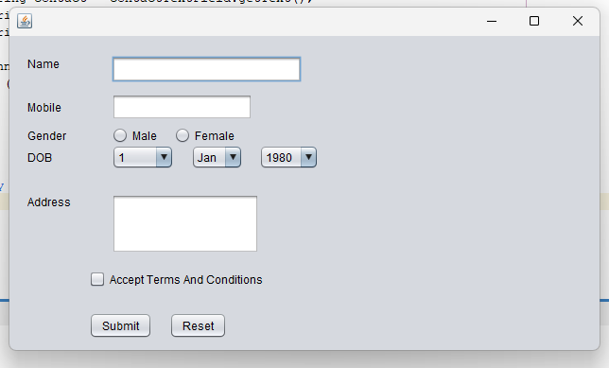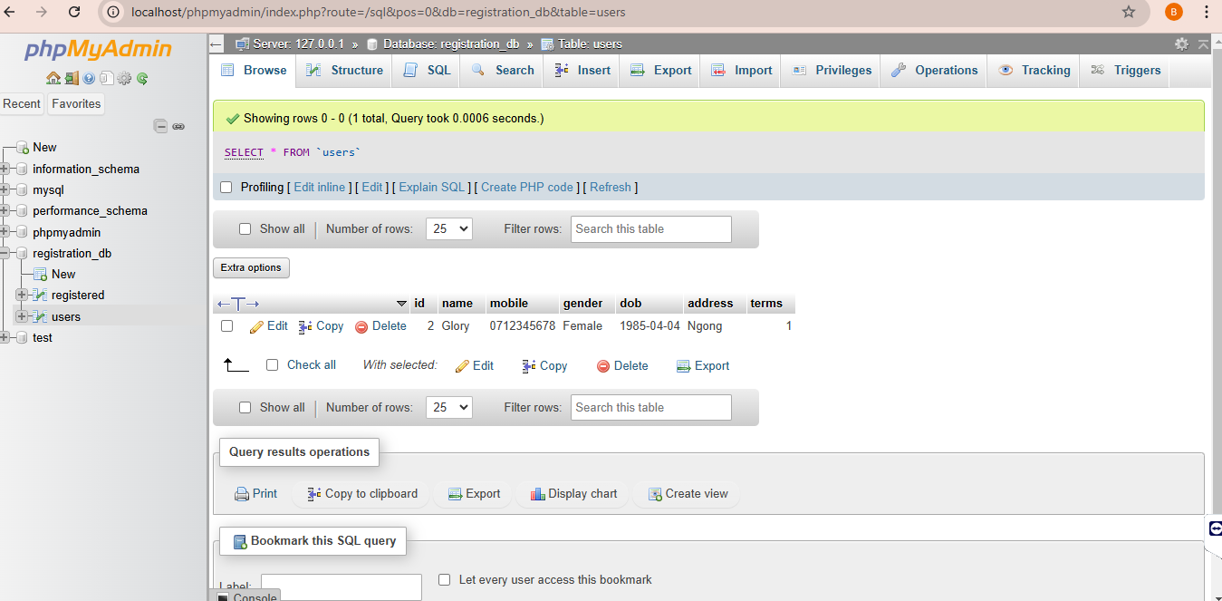

This is the source code of the Form above:

import javax.swing.JOptionPane;

import java.sql.*;

import java.sql.DriverManager;

import java.sql.SQLException;

/*

* Click nbfs://nbhost/SystemFileSystem/Templates/Licenses/license-default.txt to change this license

* Click nbfs://nbhost/SystemFileSystem/Templates/GUIForms/JFrame.java to edit this template

*/

/**

*

* @author Alchemist

*/

public class Registration1Frame extends javax.swing.JFrame {

/**

* Creates new form Registration1Frame

*/

public Registration1Frame() {

initComponents();

int currentYear = java.util.Calendar.getInstance().get(java.util.Calendar.YEAR);

for (int year = 1980; year <= currentYear; year++) {

yearComboBox.addItem(String.valueOf(year));

}

Connection con = DBConnection.connect();

if (con != null) {

System.out.println("Connection object created successfully.");

} else {

System.out.println("Failed to create a connection object. Check your DB configuration.");

}

}

public class DBConnection {

public static Connection connect() {

Connection con = null;

try {

String url = "jdbc:mysql://localhost:3306/registration_db";

String user = "root"; // Default username for XAMPP

String password = ""; // Default password for XAMPP (blank)

Class.forName("com.mysql.cj.jdbc.Driver");

con = DriverManager.getConnection(url, user, password);

System.out.println("Database connected successfully!");

} catch (ClassNotFoundException e) {

System.err.println("JDBC Driver not found: " + e.getMessage());

} catch (SQLException e) {

System.err.println("Error connecting to database: " + e.getMessage());

}

return con;

}

}

/**

* This method is called from within the constructor to initialize the form.

* WARNING: Do NOT modify this code. The content of this method is always

* regenerated by the Form Editor.

*/

@SuppressWarnings("unchecked")

// <editor-fold defaultstate="collapsed" desc="Generated Code">

private void initComponents() {

buttonGroup = new javax.swing.ButtonGroup();

jLabel1 = new javax.swing.JLabel();

jLabel2 = new javax.swing.JLabel();

jLabel3 = new javax.swing.JLabel();

jLabel4 = new javax.swing.JLabel();

jLabel5 = new javax.swing.JLabel();

nameTextField = new javax.swing.JTextField();

mobileTextField = new javax.swing.JTextField();

maleRadioButton = new javax.swing.JRadioButton();

femaleRadioButton = new javax.swing.JRadioButton();

dayComboBox = new javax.swing.JComboBox<>();

monthComboBox = new javax.swing.JComboBox<>();

yearComboBox = new javax.swing.JComboBox<>();

addressTextArea = new javax.swing.JTextField();

termsCheckBox = new javax.swing.JCheckBox();

submitButton = new javax.swing.JButton();

resetButton = new javax.swing.JButton();

jPanel1 = new javax.swing.JPanel();

setDefaultCloseOperation(javax.swing.WindowConstants.EXIT_ON_CLOSE);

jLabel1.setText("Name");

jLabel2.setText("Mobile");

jLabel3.setText("Gender");

jLabel4.setText("DOB");

jLabel5.setText("Address");

nameTextField.addActionListener(new java.awt.event.ActionListener() {

public void actionPerformed(java.awt.event.ActionEvent evt) {

nameTextFieldActionPerformed(evt);

}

});

buttonGroup.add(maleRadioButton);

maleRadioButton.setText("Male");

buttonGroup.add(femaleRadioButton);

femaleRadioButton.setText("Female");

dayComboBox.setModel(new javax.swing.DefaultComboBoxModel<>(new String[] { "1", "2", "3", "4", "5", "6", "7", "8", "9", "10", "11", "12", "13", "14", "15", "16", "17", "18", "19", "20", "21", "22", "23", "24", "25", "26", "27", "28", "29", "30", "31" }));

monthComboBox.setModel(new javax.swing.DefaultComboBoxModel<>(new String[] { "Jan", "Feb", "March", "April", "May", "June", "July", "August", "Sep", "Oct", "Nov", "Dec" }));

yearComboBox.addActionListener(new java.awt.event.ActionListener() {

public void actionPerformed(java.awt.event.ActionEvent evt) {

yearComboBoxActionPerformed(evt);

}

});

addressTextArea.addActionListener(new java.awt.event.ActionListener() {

public void actionPerformed(java.awt.event.ActionEvent evt) {

addressTextAreaActionPerformed(evt);

}

});

termsCheckBox.setText("Accept Terms And Conditions ");

termsCheckBox.addActionListener(new java.awt.event.ActionListener() {

public void actionPerformed(java.awt.event.ActionEvent evt) {

termsCheckBoxActionPerformed(evt);

}

});

submitButton.setText("Submit");

submitButton.addActionListener(new java.awt.event.ActionListener() {

public void actionPerformed(java.awt.event.ActionEvent evt) {

submitButtonActionPerformed(evt);

}

});

resetButton.setText("Reset");

resetButton.addActionListener(new java.awt.event.ActionListener() {

public void actionPerformed(java.awt.event.ActionEvent evt) {

resetButtonActionPerformed(evt);

}

});

javax.swing.GroupLayout jPanel1Layout = new javax.swing.GroupLayout(jPanel1);

jPanel1.setLayout(jPanel1Layout);

jPanel1Layout.setHorizontalGroup(

jPanel1Layout.createParallelGroup(javax.swing.GroupLayout.Alignment.LEADING)

.addGap(0, 205, Short.MAX_VALUE)

);

jPanel1Layout.setVerticalGroup(

jPanel1Layout.createParallelGroup(javax.swing.GroupLayout.Alignment.LEADING)

.addGap(0, 218, Short.MAX_VALUE)

);

javax.swing.GroupLayout layout = new javax.swing.GroupLayout(getContentPane());

getContentPane().setLayout(layout);

layout.setHorizontalGroup(

layout.createParallelGroup(javax.swing.GroupLayout.Alignment.LEADING)

.addGroup(layout.createSequentialGroup()

.addGroup(layout.createParallelGroup(javax.swing.GroupLayout.Alignment.LEADING)

.addGroup(layout.createSequentialGroup()

.addGap(19, 19, 19)

.addGroup(layout.createParallelGroup(javax.swing.GroupLayout.Alignment.LEADING)

.addComponent(jLabel1)

.addComponent(jLabel2)

.addComponent(jLabel3)

.addComponent(jLabel4)

.addComponent(jLabel5))

.addGap(43, 43, 43)

.addGroup(layout.createParallelGroup(javax.swing.GroupLayout.Alignment.LEADING)

.addComponent(mobileTextField, javax.swing.GroupLayout.PREFERRED_SIZE, 149, javax.swing.GroupLayout.PREFERRED_SIZE)

.addComponent(nameTextField, javax.swing.GroupLayout.PREFERRED_SIZE, 201, javax.swing.GroupLayout.PREFERRED_SIZE)

.addGroup(layout.createSequentialGroup()

.addComponent(maleRadioButton)

.addGap(18, 18, 18)

.addComponent(femaleRadioButton))

.addGroup(layout.createSequentialGroup()

.addGroup(layout.createParallelGroup(javax.swing.GroupLayout.Alignment.TRAILING)

.addComponent(addressTextArea, javax.swing.GroupLayout.Alignment.LEADING, javax.swing.GroupLayout.PREFERRED_SIZE, 156, javax.swing.GroupLayout.PREFERRED_SIZE)

.addGroup(layout.createSequentialGroup()

.addComponent(dayComboBox, javax.swing.GroupLayout.PREFERRED_SIZE, 66, javax.swing.GroupLayout.PREFERRED_SIZE)

.addGap(18, 18, 18)

.addComponent(monthComboBox, javax.swing.GroupLayout.PREFERRED_SIZE, 55, javax.swing.GroupLayout.PREFERRED_SIZE)

.addGap(17, 17, 17)))

.addComponent(yearComboBox, javax.swing.GroupLayout.PREFERRED_SIZE, 63, javax.swing.GroupLayout.PREFERRED_SIZE))))

.addGroup(layout.createSequentialGroup()

.addGap(84, 84, 84)

.addGroup(layout.createParallelGroup(javax.swing.GroupLayout.Alignment.LEADING)

.addGroup(layout.createSequentialGroup()

.addComponent(submitButton)

.addGap(18, 18, 18)

.addComponent(resetButton))

.addComponent(termsCheckBox))))

.addPreferredGap(javax.swing.LayoutStyle.ComponentPlacement.RELATED, 52, Short.MAX_VALUE)

.addComponent(jPanel1, javax.swing.GroupLayout.PREFERRED_SIZE, javax.swing.GroupLayout.DEFAULT_SIZE, javax.swing.GroupLayout.PREFERRED_SIZE)

.addGap(40, 40, 40))

);

layout.setVerticalGroup(

layout.createParallelGroup(javax.swing.GroupLayout.Alignment.LEADING)

.addGroup(layout.createSequentialGroup()

.addGap(21, 21, 21)

.addGroup(layout.createParallelGroup(javax.swing.GroupLayout.Alignment.LEADING)

.addComponent(jLabel1)

.addComponent(nameTextField, javax.swing.GroupLayout.PREFERRED_SIZE, javax.swing.GroupLayout.DEFAULT_SIZE, javax.swing.GroupLayout.PREFERRED_SIZE))

.addGroup(layout.createParallelGroup(javax.swing.GroupLayout.Alignment.LEADING)

.addGroup(layout.createSequentialGroup()

.addGap(12, 12, 12)

.addGroup(layout.createParallelGroup(javax.swing.GroupLayout.Alignment.BASELINE)

.addComponent(jLabel2)

.addComponent(mobileTextField, javax.swing.GroupLayout.PREFERRED_SIZE, javax.swing.GroupLayout.DEFAULT_SIZE, javax.swing.GroupLayout.PREFERRED_SIZE))

.addGap(7, 7, 7)

.addGroup(layout.createParallelGroup(javax.swing.GroupLayout.Alignment.BASELINE)

.addComponent(jLabel3)

.addComponent(maleRadioButton)

.addComponent(femaleRadioButton))

.addGap(1, 1, 1)

.addGroup(layout.createParallelGroup(javax.swing.GroupLayout.Alignment.BASELINE)

.addComponent(jLabel4)

.addComponent(dayComboBox, javax.swing.GroupLayout.PREFERRED_SIZE, javax.swing.GroupLayout.DEFAULT_SIZE, javax.swing.GroupLayout.PREFERRED_SIZE)

.addComponent(monthComboBox, javax.swing.GroupLayout.PREFERRED_SIZE, javax.swing.GroupLayout.DEFAULT_SIZE, javax.swing.GroupLayout.PREFERRED_SIZE)

.addComponent(yearComboBox, javax.swing.GroupLayout.PREFERRED_SIZE, javax.swing.GroupLayout.DEFAULT_SIZE, javax.swing.GroupLayout.PREFERRED_SIZE))

.addGap(26, 26, 26)

.addGroup(layout.createParallelGroup(javax.swing.GroupLayout.Alignment.LEADING)

.addComponent(jLabel5)

.addComponent(addressTextArea, javax.swing.GroupLayout.PREFERRED_SIZE, 63, javax.swing.GroupLayout.PREFERRED_SIZE))

.addGap(18, 18, 18)

.addComponent(termsCheckBox)

.addGap(26, 26, 26))

.addGroup(javax.swing.GroupLayout.Alignment.TRAILING, layout.createSequentialGroup()

.addPreferredGap(javax.swing.LayoutStyle.ComponentPlacement.RELATED)

.addComponent(jPanel1, javax.swing.GroupLayout.PREFERRED_SIZE, javax.swing.GroupLayout.DEFAULT_SIZE, javax.swing.GroupLayout.PREFERRED_SIZE)

.addGap(18, 18, 18)))

.addGroup(layout.createParallelGroup(javax.swing.GroupLayout.Alignment.BASELINE)

.addComponent(submitButton)

.addComponent(resetButton))

.addContainerGap(12, Short.MAX_VALUE))

);

pack();

}// </editor-fold>

private void nameTextFieldActionPerformed(java.awt.event.ActionEvent evt) {

// TODO add your handling code here:

}

private void termsCheckBoxActionPerformed(java.awt.event.ActionEvent evt) {

// TODO add your handling code here:

}

private void submitButtonActionPerformed(java.awt.event.ActionEvent evt) {

String name = nameTextField.getText();

String mobile = mobileTextField.getText();

String gender = maleRadioButton.isSelected() ? "Male" : "Female";

String day = (String) dayComboBox.getSelectedItem();

String year = (String) yearComboBox.getSelectedItem();

//YYYYY/MM/DD

String dob = year + "-" + String.format("%02d", monthComboBox.getSelectedIndex() + 1) + "-" + day;

String address = addressTextArea.getText();

if (!termsCheckBox.isSelected()) {

JOptionPane.showMessageDialog(this, "Please accept the Terms and Conditions before submitting.",

"Terms and Conditions", JOptionPane.WARNING_MESSAGE);

return;

}

Connection con = DBConnection.connect();

if (con == null) {

JOptionPane.showMessageDialog(this, "Failed to connect to the database. Please check your configuration.",

"Database Error", JOptionPane.ERROR_MESSAGE);

return;

}

try (PreparedStatement pst = con.prepareStatement(

"INSERT INTO users (name, mobile, gender, dob, address, terms) VALUES (?, ?, ?, ?, ?, ?)")) {

pst.setString(1, name);

pst.setString(2, mobile);

pst.setString(3, gender);

pst.setString(4, dob);

pst.setString(5, address);

pst.setBoolean(6, true); // Indicate terms were accepted

pst.executeUpdate();

JOptionPane.showMessageDialog(this, "Registration Successful!");

} catch (SQLException ex) {

ex.printStackTrace();

JOptionPane.showMessageDialog(this, "Error saving data. Please try again.");

}

}

private void addressTextAreaActionPerformed(java.awt.event.ActionEvent evt) {

// TODO add your handling code here:

}

private void resetButtonActionPerformed(java.awt.event.ActionEvent evt) {

nameTextField.setText("");

mobileTextField.setText("");

buttonGroup.clearSelection();

dayComboBox.setSelectedIndex(0);

monthComboBox.setSelectedIndex(0);

yearComboBox.setSelectedIndex(0);

addressTextArea.setText("");

termsCheckBox.setSelected(false);

// TODO add your handling code here:

}

private void yearComboBoxActionPerformed(java.awt.event.ActionEvent evt) {

// TODO add your handling code here:

}

/**

* @param args the command line arguments

*/

public static void main(String args[]) {

/* Set the Nimbus look and feel */

//<editor-fold defaultstate="collapsed" desc=" Look and feel setting code (optional) ">

/* If Nimbus (introduced in Java SE 6) is not available, stay with the default look and feel.

* For details see http://download.oracle.com/javase/tutorial/uiswing/lookandfeel/plaf.html

*/

try {

for (javax.swing.UIManager.LookAndFeelInfo info : javax.swing.UIManager.getInstalledLookAndFeels()) {

if ("Nimbus".equals(info.getName())) {

javax.swing.UIManager.setLookAndFeel(info.getClassName());

break;

}

}

} catch (ClassNotFoundException ex) {

java.util.logging.Logger.getLogger(Registration1Frame.class.getName()).log(java.util.logging.Level.SEVERE, null, ex);

} catch (InstantiationException ex) {

java.util.logging.Logger.getLogger(Registration1Frame.class.getName()).log(java.util.logging.Level.SEVERE, null, ex);

} catch (IllegalAccessException ex) {

java.util.logging.Logger.getLogger(Registration1Frame.class.getName()).log(java.util.logging.Level.SEVERE, null, ex);

} catch (javax.swing.UnsupportedLookAndFeelException ex) {

java.util.logging.Logger.getLogger(Registration1Frame.class.getName()).log(java.util.logging.Level.SEVERE, null, ex);

}

//</editor-fold>

/* Create and display the form */

java.awt.EventQueue.invokeLater(new Runnable() {

public void run() {

new Registration1Frame().setVisible(true);

}

});

}

// Variables declaration - do not modify

private javax.swing.JTextField addressTextArea;

private javax.swing.ButtonGroup buttonGroup;

private javax.swing.JComboBox<String> dayComboBox;

private javax.swing.JRadioButton femaleRadioButton;

private javax.swing.JLabel jLabel1;

private javax.swing.JLabel jLabel2;

private javax.swing.JLabel jLabel3;

private javax.swing.JLabel jLabel4;

private javax.swing.JLabel jLabel5;

private javax.swing.JPanel jPanel1;

private javax.swing.JRadioButton maleRadioButton;

private javax.swing.JTextField mobileTextField;

private javax.swing.JComboBox<String> monthComboBox;

private javax.swing.JTextField nameTextField;

private javax.swing.JButton resetButton;

private javax.swing.JButton submitButton;

private javax.swing.JCheckBox termsCheckBox;

private javax.swing.JComboBox<String> yearComboBox;

// End of variables declaration

}